ASSESSMENT TOOL III – PENETRATION TESTING TASK
COURSE CODE: ITA1412
COURSE NAME: Ethical Hacking
NAME :G.MUTHUKUMARA
REG.NO:192511293

QUESTION 1 – EXTERNAL RECONNAISSANCE USING THEHARVESTER

Aim
To examine the publicly available footprint of the authorized domain tesla.com using theHarvester and determine what information can be obtained through passive reconnaissance techniques.

Tool Required theHarvester Target Domain tesla.com
Purpose of the Experiment
The purpose of this exercise is to understand how information published on public sources can reveal details about an organization's external infrastructure. The collected information can then be
categorized and evaluated from a security perspective.

Methodology
TheHarvester was executed against the authorized domain to collect information available through supported public sources. The reconnaissance focused on identifying:
- Public email addresses
- Subdomains
- Hostnames
- IP addresses
- URLs
- Domain-related infrastructure
- Other publicly indexed information

Command Executed
theHarvester -d tesla.com -b all

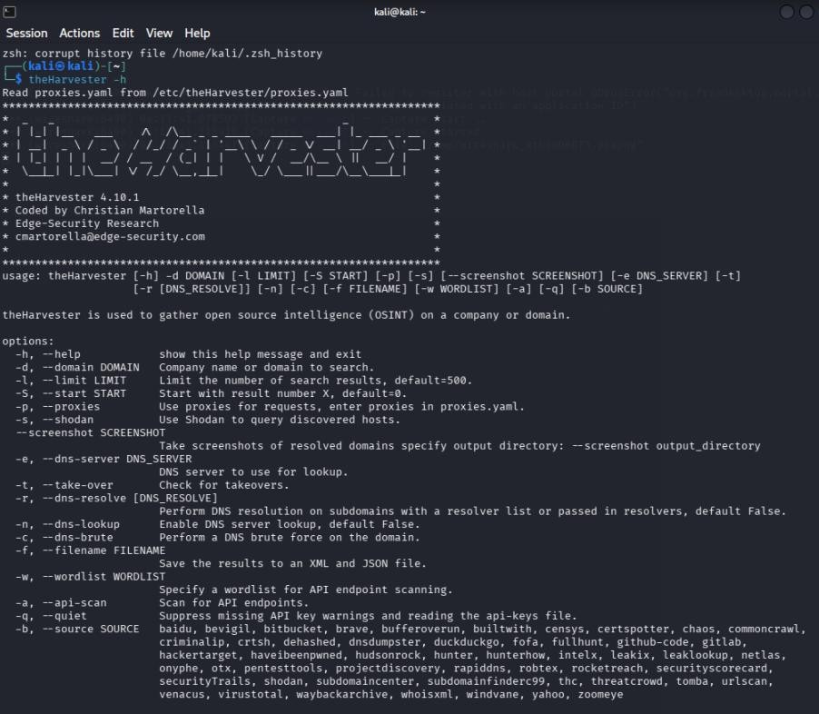
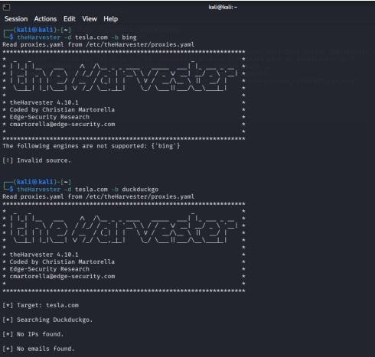
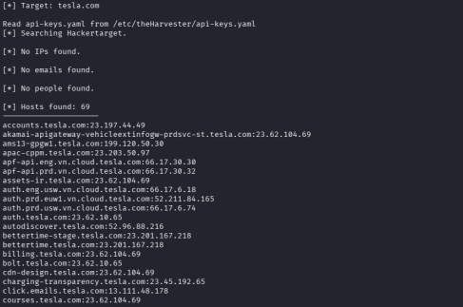

Results
The information obtained from the reconnaissance should be entered based on the actual output generated during execution.

Analysis
Reconnaissance information can provide an attacker with an initial understanding of an
organization's internet-facing environment. Email addresses may reveal potential employee identities and could be useful in targeted social-engineering campaigns.
Similarly, subdomains and hostnames may expose additional applications and services. When the information is combined with DNS queries and service discovery, an attacker can gradually construct a map of the organization's public infrastructure.

Security Concerns
The major concerns associated with excessive information disclosure include:
- Increased visibility of the external attack surface.
- Discovery of unused or forgotten subdomains.
- Identification of employee email addresses.
- Identification of externally hosted applications.
- Easier preparation of targeted phishing attempts.
- Better understanding of infrastructure naming patterns.

Recommendations
The organization should maintain an external asset inventory and regularly review publicly available information. Unused domains and subdomains should be removed. Employee information should be exposed only when necessary, and externally accessible services should be properly secured.
Continuous monitoring of public-facing assets can also help identify unexpected exposure.

Conclusion
The exercise showed that passive reconnaissance can provide useful information without directly interacting with internal systems. Organizations should therefore consider public information disclosure as part of their overall attack-surface management strategy.

QUESTION 2 – WEB SERVER ANALYSIS USING NIKTO

Aim
To examine the security posture of the authorized web application testphp.vulnweb.com using Nikto and identify possible weaknesses related to web-server configuration, exposed resources, HTTP methods, and information disclosure.

Tool Required Nikto

Target testphp.vulnweb.com Methodology
Nikto was used to perform automated checks against the authorized web server. The scan output was reviewed to identify findings that may require further investigation.
The assessment considered:
- Server information
- Exposed files
- Accessible directories
- HTTP methods
- Configuration problems
- Potentially outdated software
- Information-disclosure issues

Command Executed
nikto -h http://testphp.vulnweb.com
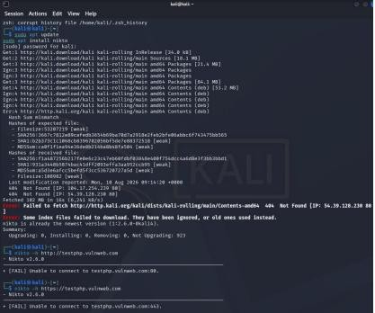
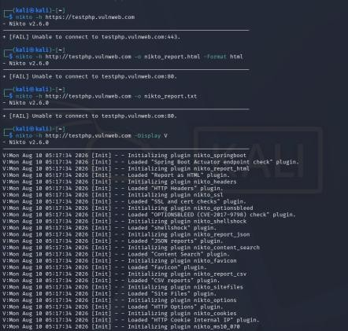

Interpretation
Nikto identifies potential weaknesses, but automated scanner output must be interpreted carefully. A scanner message does not automatically mean that a confirmed exploitable vulnerability exists.
For example, server information can help identify the technology stack. Exposed directories may provide access to resources that should not be publicly available. Similarly, unnecessary HTTP methods can increase the number of possible interactions with a web server.

Security Impact
If sensitive resources or outdated components are exposed, attackers may gain useful information for further testing. Information disclosure may also simplify technology fingerprinting and vulnerability research.

Suggested Remediation
- Remove unnecessary web-server files.
- Restrict sensitive directories.
- Turn off unnecessary directory browsing.
- Disable unused HTTP methods.
- Keep server software and dependencies updated.
- Review server configuration regularly.
- Avoid exposing unnecessary software-version details.
- Protect administrative resources with suitable authentication and authorization.

Verification
A follow-up scan should be performed after remediation. Previously identified findings should be checked individually to verify whether the exposure has been eliminated.

Conclusion
The Nikto assessment demonstrated how automated web-server testing can identify potential configuration weaknesses and information-disclosure issues. Proper configuration management, patching, access restrictions, and periodic testing can reduce the web application's external exposure.

QUESTION 3 – DNS INFORMATION GATHERING USING DIG

Aim
To investigate DNS information associated with zonetransfer.me using the Dig utility and determine whether DNS configuration exposes excessive infrastructure information or permits an unauthorized zone transfer.

Tool Required Dig

Target Domain zonetransfer.me Methodology
DNS queries were performed for several record types to understand the structure of the target domain.

IPv4 Address
dig zonetransfer.me A

IPv6 Address
dig zonetransfer.me AAAA

Mail Servers
dig zonetransfer.me MX

Name Servers
dig zonetransfer.me NS

Canonical Name
dig zonetransfer.me CNAME

Text Records
dig zonetransfer.me TXT

Start of Authority
dig zonetransfer.me SOA

Zone Transfer Verification
After identifying the authoritative server:
dig AXFR zonetransfer.me @<authoritative-server>
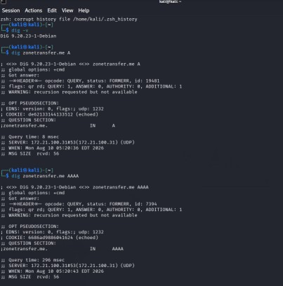

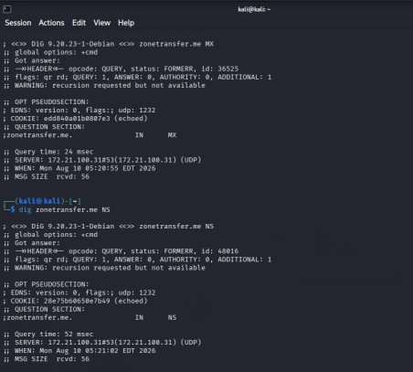
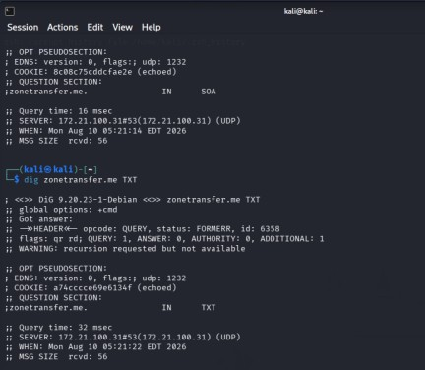

Analysis
DNS is an important source of infrastructure information. A DNS lookup may reveal IP addresses, authoritative servers, mail systems, and relationships between different hostnames.
MX records can expose mail-server infrastructure, while NS records identify the authoritative DNS servers. CNAME entries may show connections between aliases and actual services.
A successful AXFR response is more serious because it can potentially provide a large collection of
records belonging to the DNS zone. Such information could help an attacker discover additional hosts and services.

Security Risks
Potential risks include:
- Disclosure of infrastructure details.

- Discovery of mail servers.
- Exposure of server naming patterns.
- Identification of relationships between services.
- Increased effectiveness of further reconnaissance.
- Excessive information exposure through unrestricted zone transfer.

Security Recommendations
The DNS infrastructure should allow zone transfers only to authorized secondary DNS servers. Public DNS records should be periodically reviewed to remove obsolete entries.
DNS administrators should also monitor unauthorized configuration changes and ensure that access controls are correctly applied.

Verification of Fix
After restricting zone transfers, an AXFR request should be tested again from an unauthorized location. The expected result should be refusal of the transfer while authorized DNS replication continues to work normally.

Conclusion
The DNS assessment demonstrated that DNS records can provide considerable information about an organization's infrastructure. Restricting zone transfers and maintaining clean, accurate DNS records can reduce unnecessary information disclosure.

QUESTION 4 – WINDOWS SMB ENUMERATION USING ENUM4LINUX

Aim
To analyze the SMB and NetBIOS exposure of the authorized Windows system 192.168.1.100 using Enum4linux and determine what information is available without attempting exploitation.

Tool Required Enum4linux Target
192.168.1.100

Objective
The exercise focuses on identifying information such as:
- Windows system details
- Users
- Groups
- Shared folders

- Domain/workgroup information
- Password policy
- NetBIOS information
- SMB configuration details
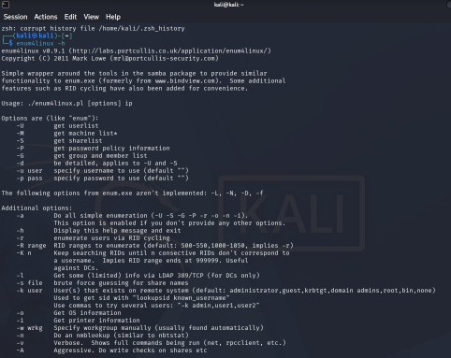
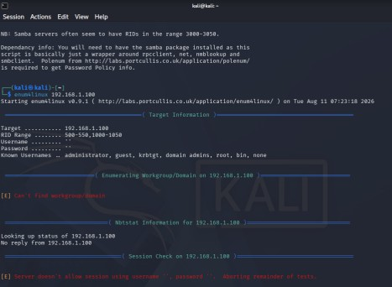

Commands Used Comprehensive Enumeration enum4linux -a 192.168.1.100 User Enumeration
enum4linux -U 192.168.1.100

Group Enumeration
enum4linux -G 192.168.1.100

Share Enumeration
enum4linux -S 192.168.1.100 Operating-System Details enum4linux -o 192.168.1.100 Password Policy
enum4linux -P 192.168.1.100

NetBIOS Details
enum4linux -n 192.168.1.100

Security Assessment
SMB enumeration can reveal information about the organization’s Windows environment. Usernames can potentially provide a starting point for credential-related attacks, while group information can help identify account relationships.
If SMB shares are accessible with weak permissions, unauthorized users may be able to view or modify files. Domain information can also help an attacker understand the organization’s Windows architecture.
The presence of anonymous or null-session enumeration should be carefully reviewed because it may expose information without requiring normal authentication.

Risks
- User and group information exposure.
- Improperly secured shared resources.
- Weak SMB access controls.
- Increased credential-attack opportunities.
- Possible assistance in lateral movement.
- Disclosure of domain architecture.

Recommendations
- Restrict anonymous SMB enumeration.
- Apply least-privilege permissions to shared resources.
- Remove unnecessary shares.
- Restrict SMB access to trusted networks.
- Apply security patches to Windows systems.
- Enforce strong authentication policies.
- Review group membership and privileges.
- Monitor SMB connections and authentication attempts.

- Segment sensitive systems from general network traffic.

Remediation Validation
Enum4linux should be executed again after the security changes. The organization should verify that unnecessary users, groups, shares, and configuration information are no longer accessible to unauthorized users.

Conclusion
The assessment demonstrated the importance of securing SMB and NetBIOS services. Excessive enumeration information can assist attackers during later stages of an attack. Proper access control, network segmentation, authentication, and secure SMB configuration can reduce these risks.

QUESTION 5 – TCP SERVICE ENUMERATION USING NETCAT

Aim
To use Netcat to communicate with an authorized TCP service on scanme.nmap.org and examine the information returned by the service for banner and technology identification.

Tool Required Netcat (nc)
Target
scanme.nmap.org

Purpose
The exercise is designed to understand how service responses can expose information about protocols, server technologies, HTTP headers, and implementation details.

Procedure
A verbose TCP connection was established to the authorized HTTP service. nc -v scanme.nmap.org 80
An HTTP request was then submitted:
GET / HTTP/1.1
Host: scanme.nmap.org Connection: close

Analysis
A service banner can reveal information about the software and protocol running on a particular port. HTTP headers can also expose implementation details.
From a defensive perspective, the disclosure of a software version is not necessarily a vulnerability. However, the information may make fingerprinting easier. An attacker could potentially compare an

identified software version against known vulnerability databases and determine whether additional investigation is justified.
Therefore, any suspected vulnerability must be manually verified before being classified as confirmed.
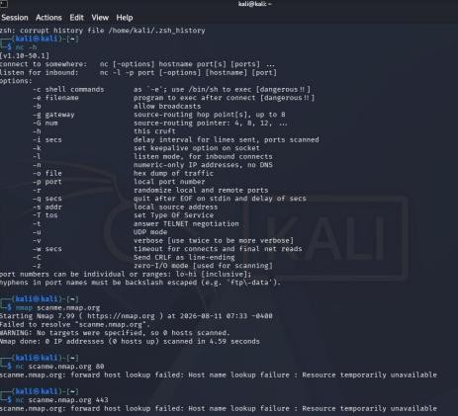
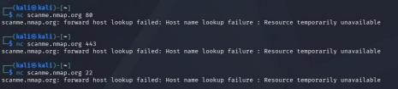

Potential Impact
Service information disclosure may:
- Make technology identification easier.
- Reveal software implementation details.
- Help attackers select targeted testing methods.
- Provide information for vulnerability research.
- Reduce the uncertainty involved in reconnaissance.

Recommendations
The organization should regularly review all internet-facing services and disable those that are not required. Services that must remain accessible should be patched and securely configured.
Where practical, unnecessary version information should not be exposed through banners or response headers. Firewall rules should also restrict access to required ports only.

Remediation Verification

After applying the required configuration changes, the service should be contacted again using an approved tool. The response should be compared with the original result to confirm that
unnecessary information has been reduced.

Conclusion
Netcat demonstrated that even a basic TCP connection can reveal useful information about a service. Service-banner exposure is primarily an information-disclosure concern, but it can make subsequent attacks more focused. Regular service reviews, patch management, access restrictions, and careful configuration can reduce the available information.

